INTERNATIONAL ORGANISATION FOR STANDARDISATION
ORGANISATION INTERNATIONALE DE NORMALISATION
ISO/IEC JTC1/SC29/WG11
CODING OF MOVING PICTURES AND AUDIO

ISO/IEC JTC1/SC29/WG11 W16351
June 2016, Geneva, CH

Source: Communication Group
Title: White Paper on Compact Descriptors for Visual Search
Authors: Miroslaw Bober, Werner Bailer, Stavros Paschalakis, Jie Chen

Compact Descriptors for Visual Search (CDVS) –
The Standard for Image Search

Looking for images of your house in your gigantic image collection? Searching for a product on the Internet, when all you have is an old photograph? Trying to recognize a wine bottle from its label? Building a virtual reality or a navigation app?
While some of these applications exist today, there is no interoperability between metadata and services generated by different providers. MPEG CVDS brings a unified and interoperable framework for devices and services in the area of visual search and object instance recognition. Achieving interoperability is essential for building a unified and rich ecosystem including multiple stakeholders, enabling new content and services and therefore stimulating growth of the market. MPEG CVDS was developed to enable just that by specifying a standard image description tool designed to enable efficient and interoperable visual search applications, allowing visual content matching in images.

Why do we need CDVS?
The size of users' digital media collections are growing exponentially, with millions of images and videos added to the servers daily. For example, every second 725 photos are posted on Instagram, more than 2,000 to Facebook and about 50 hours of video are uploaded to Youtube. Navigating through these petabytes of visual data and organising them is hard without appropriate visual search tools. CDVS tools support quick and efficient visual search, enabling access to even the largest image databases.
Camera equipped mobile devices, such as mobile phones or tablets are becoming platforms of choice for deployment of visual search, augmented reality, and related applications. Many applications involve the analysis of visual information and exchange of related metadata with remote servers. The scalability, response time and usability of a multimedia search system depends critically on the format and volume of the data interchanged. Image descriptors capable of matching parts of the depicted scene often reach a size not much smaller than the actual image. Thus, compactness of such descriptors has become increasingly important, but an interoperable solution did not exist prior to CDVS.

Below we present some example applications enabled by the MPEG CDVS standard in detail.

Mobile visual search
Using a mobile device, the user takes a picture and, upon identification of the captured content, receives additional information, for example:
- Information about goods (CD/DVD covers, books, newspapers, wine labels, etc.) for e-commerce.
- Information about landmarks for travel guides.
- Information about visual art for museum guides.

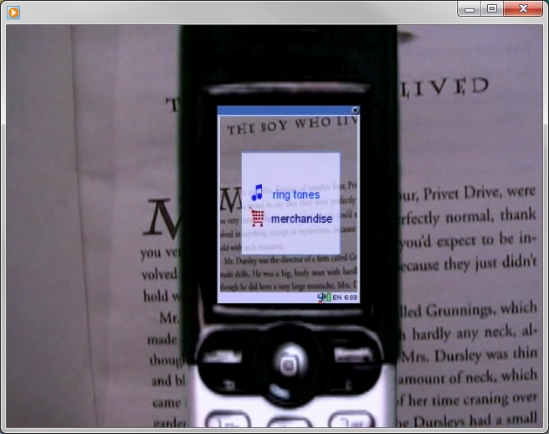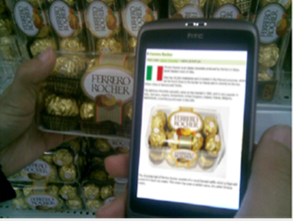
Figure 1: Example of mobile visual search: search for information about goods.

Figure 2: Example of mobile visual search: search for information about landmarks and arts.

Mobile augmented reality applications
It can be considered as an advanced (and more challenging) usage of mobile visual search: in this case users are not expected to take pictures, just by pointing a mobile device at a scene of interest they can enjoy some additional information displayed on top of an image of the real world. Examples of applications include:
- Enhanced localization and indoor navigation;
- Games;
- Continuous annotation of camera video input (e.g. in museums, cities, shopping centers);
- Professional applications aiding maintenance operations.

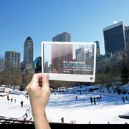
Figure 2: Example of mobile of augmented reality application (enhanced navigation).

TV/IPTV – related applications
Through a set top box, receiving broadcast/broadband programs, additional information about the content are linked and synchronized to the video stream, allowing the user to interact through rich media interfaces. The visual search functionalities rely on the same architectures described in the previous section even if in this scenario, queries are not initiated by data acquired by a camera but streamed from a provider. Examples of applications include:
- Recognition of landmarks and objects in video streams for augmented viewing experience.
- Recognition of logos/products for advertising/online shopping applications.

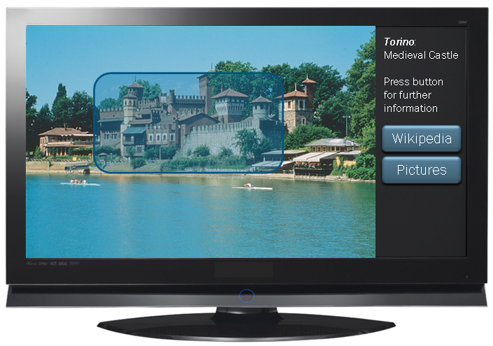
Figure 3: Examples of TV/IPTV related applications.

Web-related applications
Visual search can be applied to web content: applications must deal with the huge number of images stored on distributed servers. Queries are initiated through still images stored on the client device or browsed from the web. Examples of applications include:
- Enhanced navigation of the web based on visual content.
- Product comparison based on visual search queries.
- Overlaying of real pictures over stored street views.

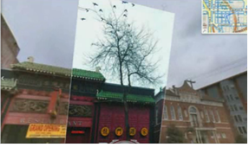
Figure 4: Examples of Web related applications.

Further applications
Applications for which CDVS technology has already been used include authoring of second applications, visual scene classification, virtual tourism applications and assisted maintenance in smart factories.
Other applications that can be enabled by CDVS include:
- Robotic vision, so that autonomous machines equipped with cameras can identify objects in their environment to enable automated actions or improve navigation abilities
- Automotive applications, such as augmented navigation for visual positioning and location based services by recognizing buildings and landmarks in key areas.
- Surveillance applications with smart cameras that can detect known content in order to highlight, count or track objects and can confirm to each other and to the service that they recognized the same object.
- Content management applications include creating links between footage, e.g. user defined, in order to organize video collections according to common objects depicted in the scenes.

Scope of MPEG CDVS and the underlying technology
The CDVS standard specifies an image description tool designed to enable efficient and interoperable visual search applications, allowing visual content matching in images. This includes matching of views of objects, landmarks, and printed documents, while being robust to partial occlusions as well as changes in viewpoint, camera parameters, and lighting conditions.
The design and development of CDVS addresses the standardization of object instance recognition technology, leveraging on a number of compelling functionalities briefly enabling a number of advantages and functionalities described below. Compression is an essential requirement for typical client-server visual search architectures. CDVS is changing the communication paradigm: Rather than sending a compressed image to a server, a set of local features are extracted from the query image and compressed into a single compact descriptor on the client side, the resulting compact descriptor is then sent to the server to initiate search. The overall size of a set of local uncompressed features (e.g. the well-known SIFT descriptor) extracted from an image can be larger than a traditionally compressed JPEG files. CDVS allows to drastically decrease the dimension of the compact visual descriptors, thanks to a scalable and adaptive compression scheme. CDVS supports different sizes of compact descriptor footprint, spanning from a maximum of 16 KB per image, which is the fully performing operating mode, down to 512 Bytes, for extremely constrained bandwidth scenarios.
A global descriptor, created from aggregated local descriptors of an image, is also embedded into the compact descriptor: the global descriptor can be matched extremely fast with similar global descriptors, thus providing means to search against extremely large scale (e.g. web scale) datasets in a shorter time.

Reference Software and Performance
The MPEG CDVS reference software is used to extract the compact descriptors for visual search from a given image. The compact descriptors can be used in pairwise matching, i.e. comparison of two image descriptors to determine the similarity between the images, and retrieval, i.e. projecting a query descriptor to a database of descriptors so as to retrieve the most similar database images to the query image.
The performance of the reference software has been evaluated on a large dataset collected by MPEG in a range of experiments. For the higher bitrate of 16 KB, CDVS achieves detection rates of between 95-99% in pair-wise comparisons (at the false alarm rate of 1%), while in retrieval a mean average precision (MAP) of 79-94% is achieved. Even for the lowest bitrate of 512 Bytes, the detection rate in pair-wise matches is 75-89% (at the false alarm rate of 1%) and the MAP in retrieval is 56-83%. The extraction time for one descriptor is around 0.2s and retrieval takes around 2.5s in a database with 1 million images. Matching and retrieval results for original resolution images are shown in Figure 5 and Figure 6.

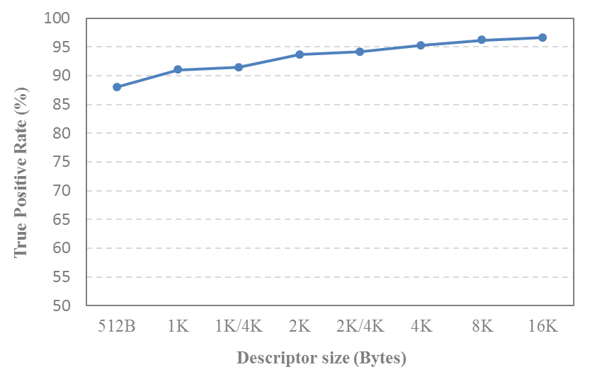
Figure 5: True-positive rate of pair-wise matching at 1% false positive rate at different descriptor sizes.

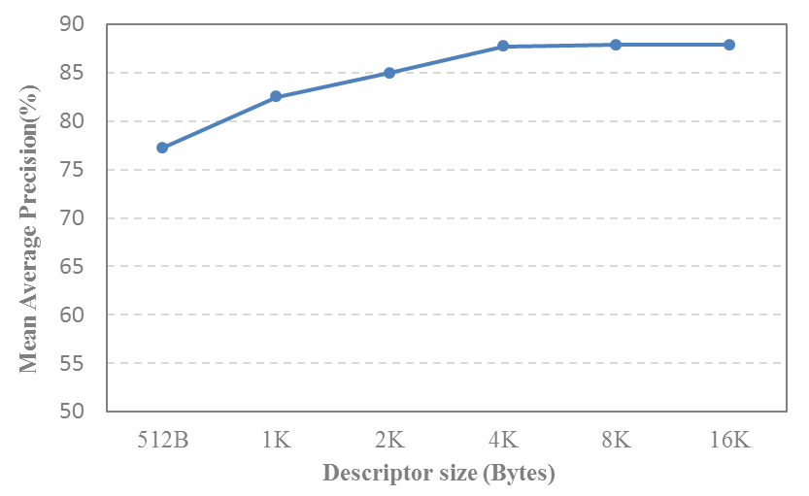
Figure 6: Mean average precision of image retrieval at different descriptor sizes.

Additional Features
The MPEG CDVS specification is a feature-rich standard. Some of the additional features are:
- Pair-wise comparisons: CDVS enables pair-wise visual content matching that is robust to partial occlusions as well as changes in vantage point, camera parameters, and lighting conditions.
- Large-scale database retrieval: CDVS provides means to search against extremely large scale (e.g. web scale) database in a shorter time thus quickly generating a short list of candidates for further refinement.
- Scalable bit-streams: CDVS supports different sizes of compact descriptor bit-streams, spanning from a maximum of 16 KB per image, down to 512 Bytes for extremely constrained bandwidth scenarios. Different sizes can efficiently interoperate.
- Hardware implementation efficiency: The development of CDVS standard has been driven by a strong hardware manufacturer industrial support, aiming at solutions with very low computational complexity, and small memory footprint thus facilitating low-power hardware implementations.
- Sufficiency: The descriptors are self-contained, no other metadata are necessary to enable search. However, CDVS descriptors can be easily combined with other relevant metadata (e.g. GPS coordinates) aiming at narrowing the scope of the search and improving retrieval efficiency.
- Generality: CDVS technology targets general-purpose scenarios: therefore, the standard solution is designed to guarantee robustness with any category of data.

The MPEG CDVS Associated Standards
The core specification of CDVS can be found in ISO/IEC 15938-13:2015: “Part 13: Compact descriptors for visual search”.
The MPEG committee has developed an additional part to add to the core specification. ISO/IEC 15938-14 “Part 14: Reference software, conformance and usage guidelines for compact descriptors for visual search” specifies the conformance and reference software implementing the normative clauses of Part 13. The usage guidelines are an informative part providing guidelines and best practices.

What’s Next?
Video content is part of an ever growing collection of professional and user generated material which will be (and actually is) definitely dominating the application scenarios on content-based search of the next years. It is acquired knowledge that visual search cannot be limited to just searching on collection of still images and that visually searching and retrieving video cannot be defined in terms of searching and retrieving the single pictures that compose the video. Current technologies and services capable to support visual search applications in video collections are in general not mutually interoperable, and this means that important industrial sectors like media and broadcasting, which own important collections of video items, cannot fully exploit their assets without risking vendor lock-in. Building on CDVS, MPEG is thus currently working on a compact descriptor for video (named CDVA), improving efficiency over CDVS by exploiting the temporal redundancy in video.

http://www.internetlivestats.com/one-second/#instagram-band
https://zephoria.com/top-15-valuable-facebook-statistics/
http://expandedramblings.com/index.php/youtube-statistics/
Presentations with details on these applications are available at http://mpeg.chiariglione.org/standards/mpeg-7/compact-descriptors-visual-search
https://en.wikipedia.org/wiki/Information_retrieval#Mean_average_precision
http://mpeg.chiariglione.org/standards/exploration/compact-descriptors-video-analysis

